Elec442/6601: Digital Signal Processing

- (12 marks) Let x(n) be a sequence whose z-transform has the pole-zero plot shown in Fig.1. Sketch the pole-zero plot for Y(z) and W(z) given
(a) 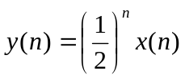, and (b) 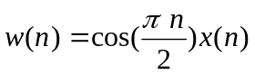.
(Please indicate all zeros and poles in your plot).

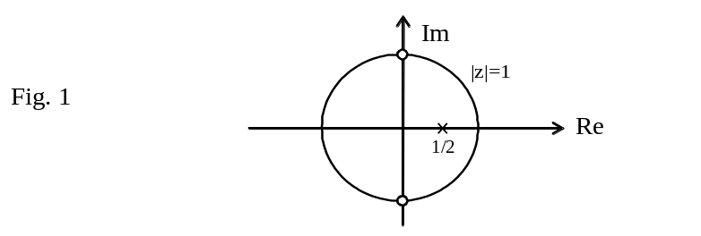

- (12 marks) A causal LTI system has impulse response h(n), for which the z-transform is
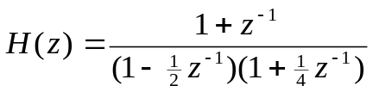

(a) What is the region of convergence of H(z)? Is the system stable? Why?
- Find the z-tranform X(z) of an input x(n) that will produce the output
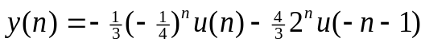
(c) Find the impulse response h(n) of the system.

- (16 marks) A sequence x(n) is obtained by sampling a continuous-time signal with period T. From this sequence a new signal having the sampling period T/2 is derived by using a linear interpolation method described by the equation
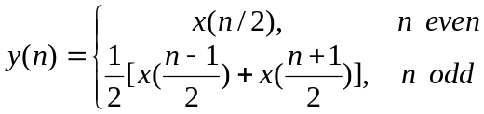
  - Determine the spectrum Y(e^{jω}) of y(n) in terms of the spectrum X(e^{jω}) of x(n).
  - Draw a diagram to implement this interpolation scheme.
  - Sketch the spectrum of y(n) when the spectrum of x(n) is


